RANA KHALED 211014597

HANIA SAMY 211005144

YOUSSEF WALAA 211004397

YOUMNA MOHAMED 211004328

breadfast

TA: REHAM KOUTA

* **Introduction:**

Breadfast, born out of a commitment to revolutionize the way Egyptians start their day, emerged as a beacon of convenience and freshness in the bustling world of online commerce. Founded with a passion for delivering quality bakery products to doorsteps, Breadfast has since evolved into a comprehensive online supermarket, offering a delightful array of breakfast essentials and groceries to households across Egypt.

In its nascent stages, Breadfast's journey was deeply rooted in the belief that mornings deserve a fresh start. Beginning with a humble assortment of bakery delights, the company quickly garnered a loyal following for its commitment to sourcing the finest ingredients and delivering them directly to customers' homes. As dawn broke, so did Breadfast's ambition, expanding its offerings beyond the realm of baked goods to encompass a diverse range of pantry staples, including fresh produce, meats, and dairy products.

Driven by a relentless pursuit of customer satisfaction, Breadfast embraced the digital landscape, crafting an intuitive online platform that seamlessly connects discerning consumers with a curated selection of premium products. With just a few clicks, customers can embark on a culinary journey, exploring a treasure trove of flavors and indulging in the convenience of doorstep delivery.

Today, Breadfast stands tall as more than just an online marketplace; it is a testament to innovation, resilience, and the power of a shared morning ritual. With a network of branches spanning the length and breadth of Egypt, Breadfast continues to redefine the breakfast experience, one delivery at a time.

* **Business type nature:**

Breadfast operates in a B2C (Business to Customer) model, serving individual customers directly through its online platform and delivery services.

* **Company Main Parties:**

Vendors/Suppliers: crystal, lion, juhayna, lamar, dina farms, abo ali, fine, edita, oxi, nivea and loreal paris.

Customers: Individual customers who place orders through the Breadfast website or app.

Main Products/Services: Fresh bakery products, breakfast items, groceries, meat, fish, and chicken.

Branches/Warehouses: Breadfast operates multiple branches and warehouses across Egypt to manage inventory and facilitate deliveries which are:

Rehab, mega mall, city center HQ, Sheraton, helioplolis, new cairo 2, 6th of October, madint nasr, sheikh Zayed, abdeen, new cairo 1, district 5, shoubra, maadi 2, obour, el sherouk, cairo festival, mokattam, mivida, rehab 3 and maadi 1

**Supply Chain Management Cycle:**

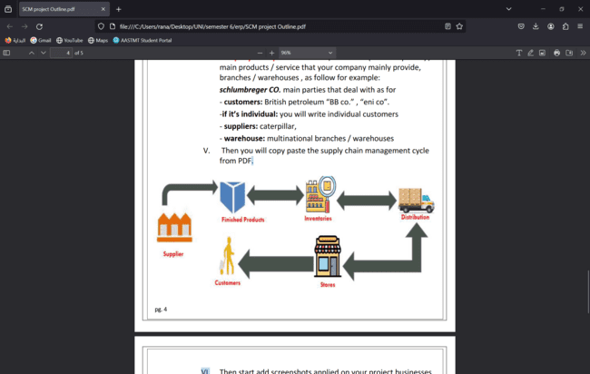

**1.Inventory:**

A.Warehouses:

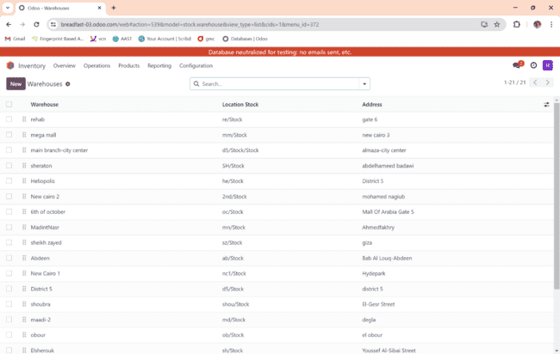

Bread fast has 21 branches all over Egypt and all the branches can resupply from each other’s.

The main branch is city center branch.

b.Product Categories:

breadfast has many product categories which are:

beauty, coffee, diaries, food cupboard, fresh juices, frozen, fruits and vegetables, home supplies ex: batteries, hot drinks, laundry detergents, meat, poultry and seafood, oriental desserts, personal care, pet supplies, pharmacy, ready to eat, snacks, stationert, supplements and tissues.

In this step we should determine the force removal strategy and costing method.

For example:

We use first in first out “fifo” because the shelf life of meat, poultry and seafood is short.

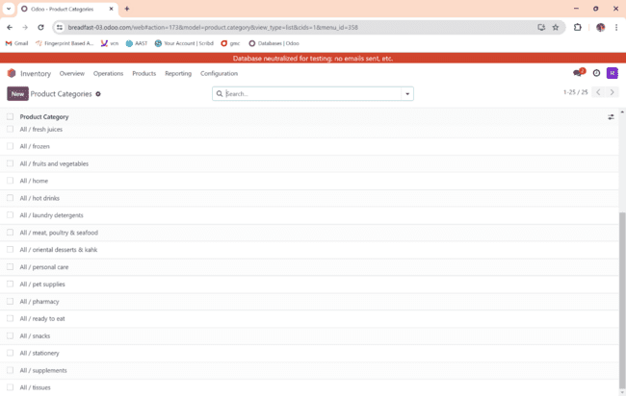

A.Inventory Operations:

We have different operation type in addition the the existing operations and each is specified to a branch and each branch can have one or more operation type; it depends on the branch capacity.

For example:

In this operation we donate to food bank from our main branch.

In each operation we should determine the type of operation, sequence prefix, warehouse, return type, default returns location and locations.

B. Add products:

We have more than 20 products and each product is assigned to its category.

B.On hand quantity:

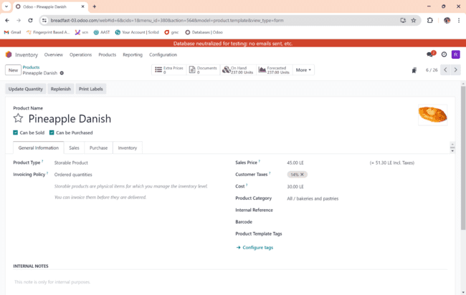

The on-hand quantity depends on the storage capacity we should determine the min quantity, max quantity and to deliver.

We should also determine the sales price, cost and assign each product to its category.

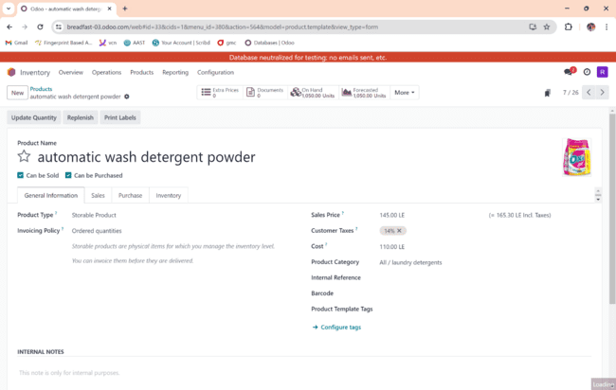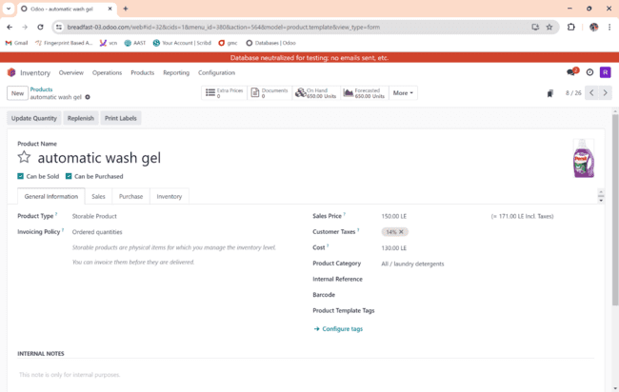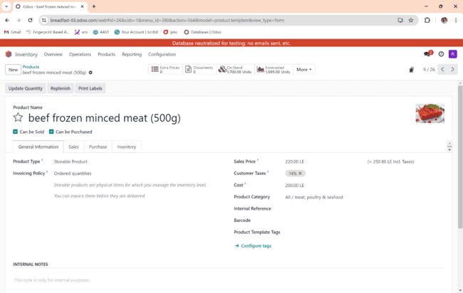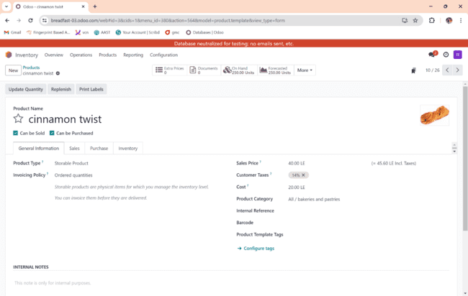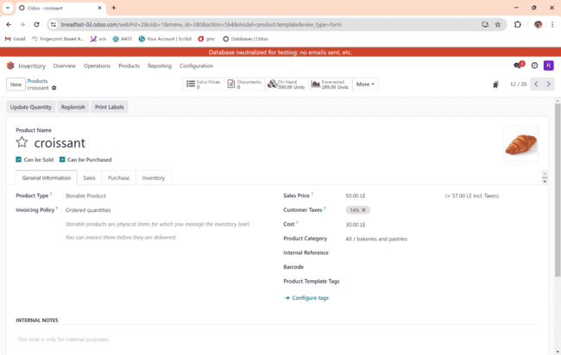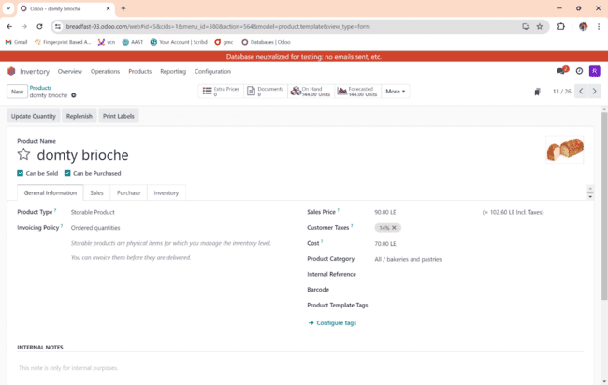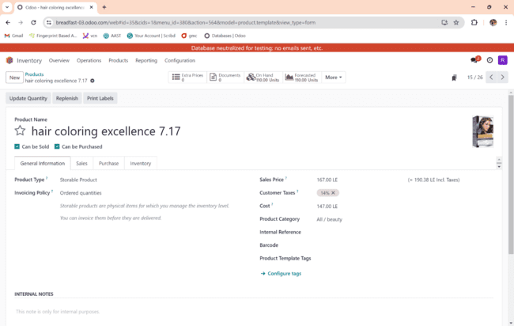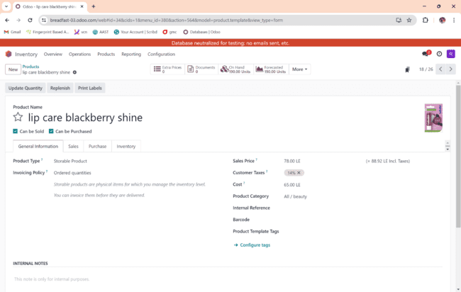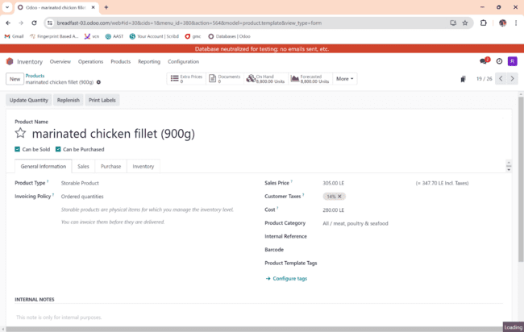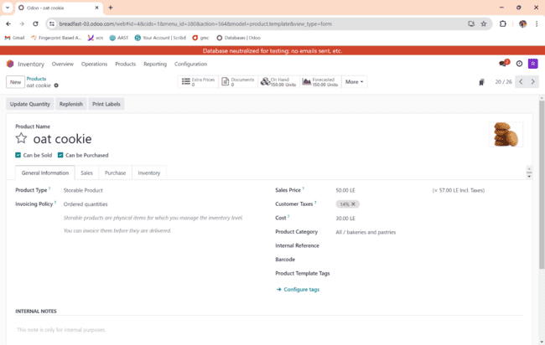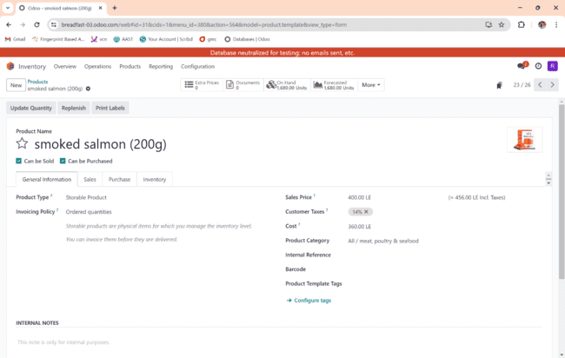

C.Reoreding rule:

At this point we should add all the products we offer and write the on hand to determine the min quantity, max quantity and to order.

In this step, we need to define the sales price and cost with general information.

And we also need to define the routes in the inventory.

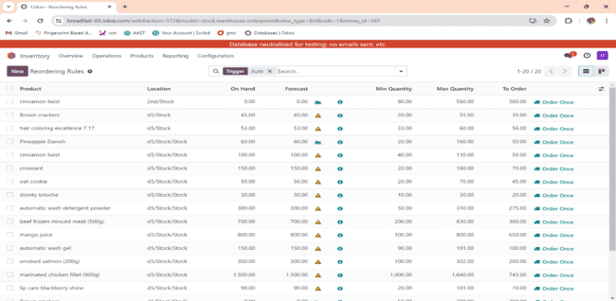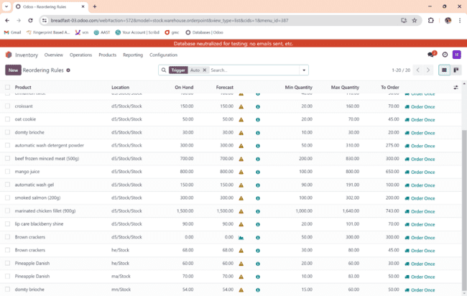

2.purchase:

At this point we request products from vendors, we have 2 billing status: waiting bills, fully billed. It depends on payment and ordering date and time.

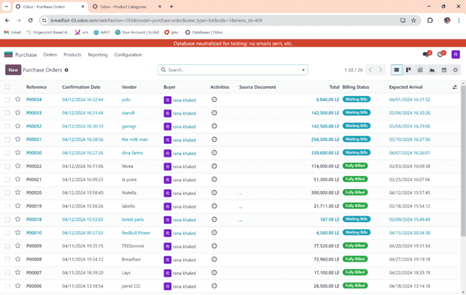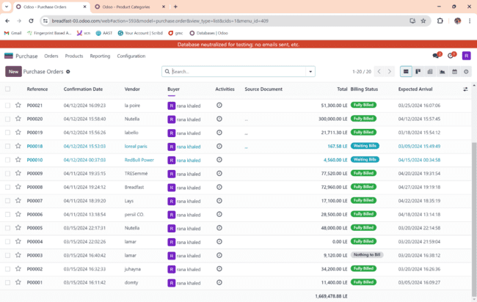B. 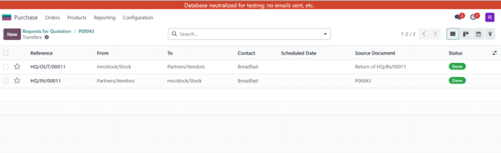

We purchase 500 orange juice then we return 100 bottle before payment date

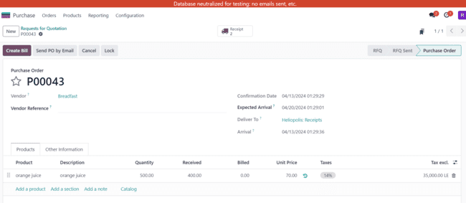

c.

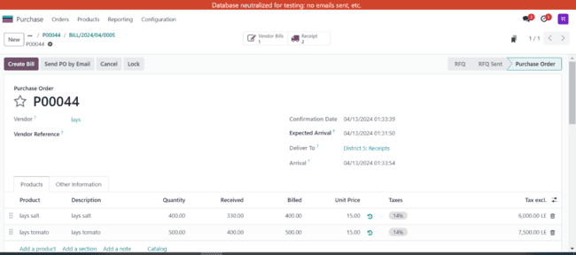

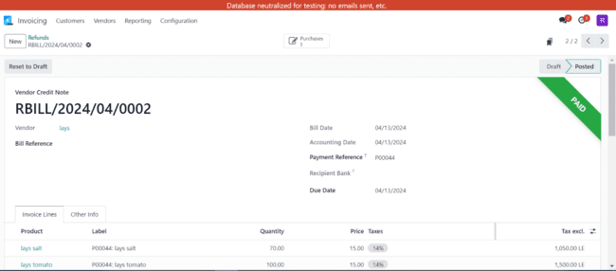

We purchase 400 bag of salt flavour and 500 from the tomato one then we find that there is 170 bag expired when they arrived and after we paid the full payment so we return the 170 bag and get a refund

c.

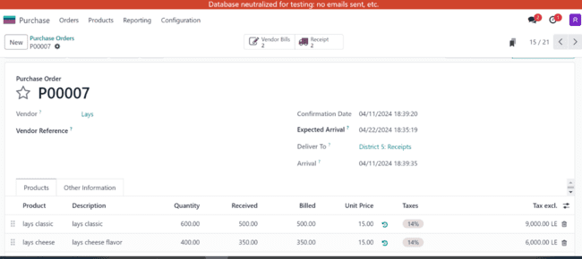

We ordered 600 and received 500 and paid only for the 500 and will pay the rest after the rest quantity arrive

d.

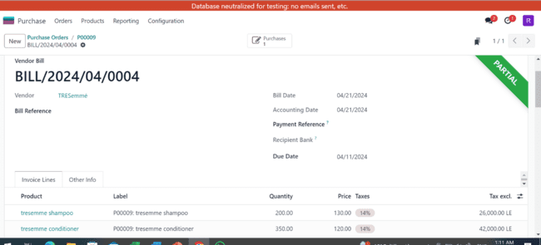

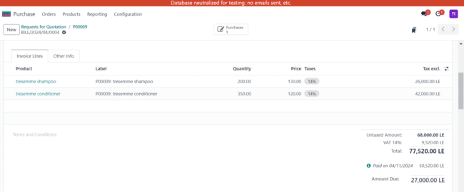

Paid part of the full amount

3.Inventory- operations:

A.internal transfer:

We do this step if the products are shipped to one warehouse and we want to distribute to other warehouses or we have a huge amount of a product in one warehouse and a little amount in another.

We need to define the contact ”which branch will receive the product”,the source location, the scheduled date, the effective date , the source document, and the product.

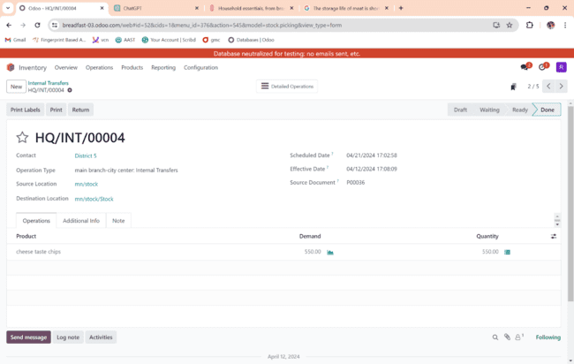

b.scrap:

we do this step to know if we have products that are damaged due to poor storage or anything that’s not related to suppliers or the manufacturer.

In this step, we need to define which products we need to throw away and its quantity.

C. Apply Receipts from the Inventory Module:

We do this step to know if the quantity we received is the same as we ordered. “inventory”

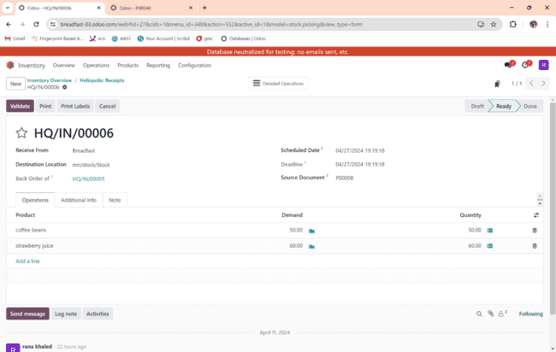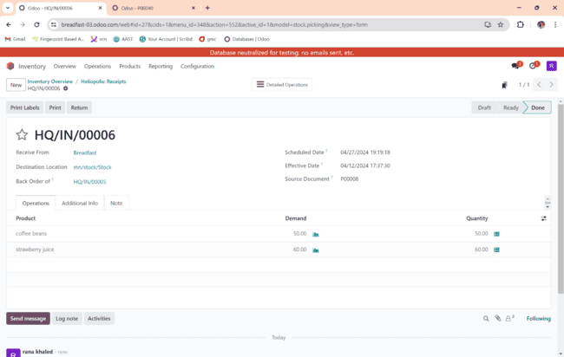

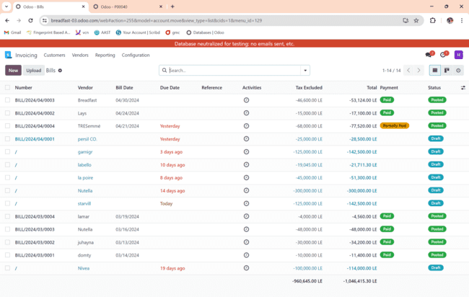

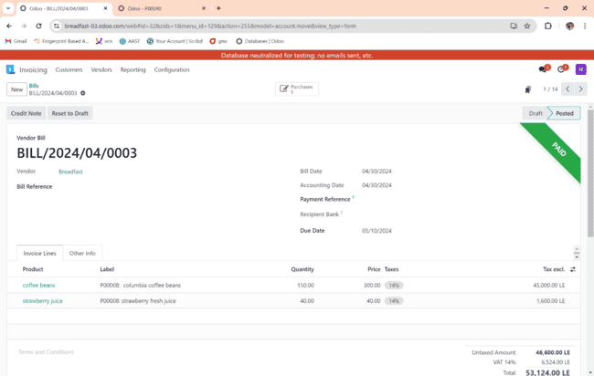

“invoicing” we do this step to confirm and validate the orders.

D. Apply Deliveries from Inventory Module:

We do this step to confirm the delivery orders, we need to define the order details”product and quantity”

For example: Malak placed an order and shoubra branch will deliver it.

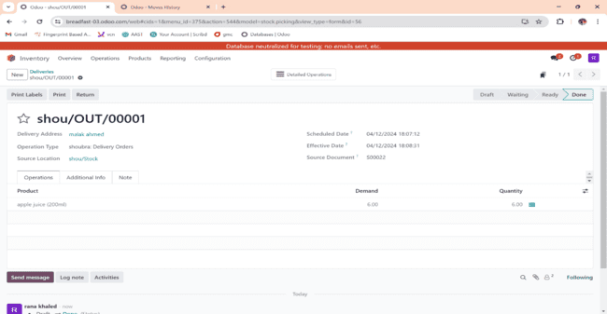

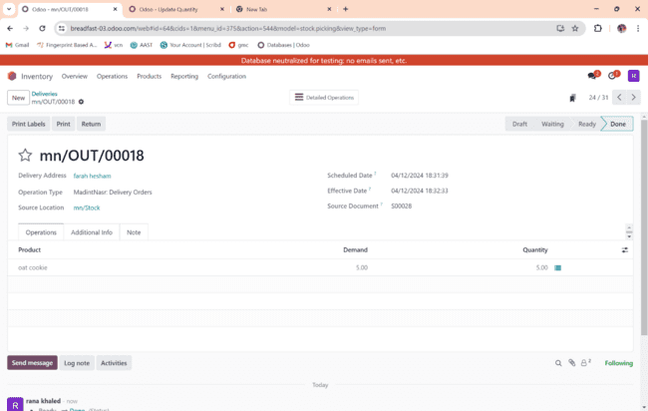

To register payment

And finally we confirmed that it is paid.

4- Sales order – Configuration:

1. Enter Sales Teams & link with warehouses:

we have a sales team in each warehouse and each sales leader has 2 or more employees who are working under him. 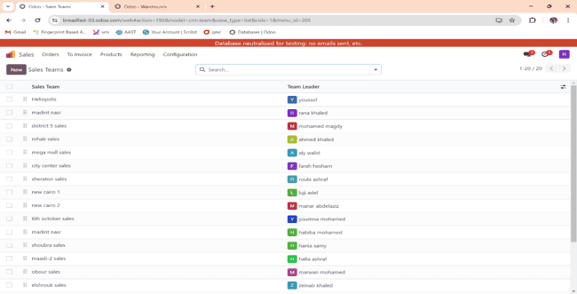

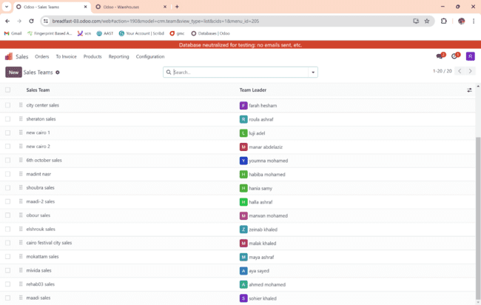

1. Inside each sales Team add 2 members minimum beside the team leader:

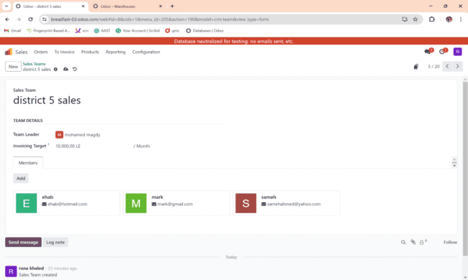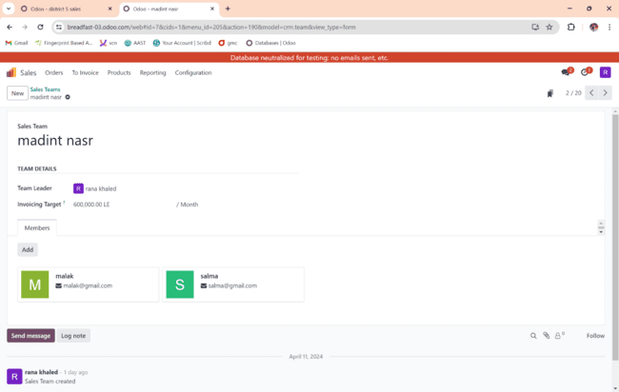

1. Show the Dashboard of all created sales Teams:

This dashboard shows each sales team's sales target and whether they’ve achieved it or not.

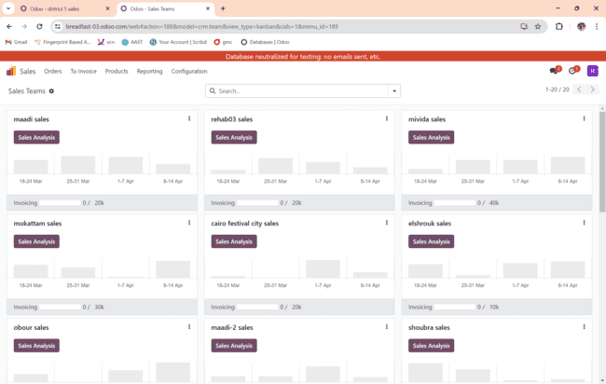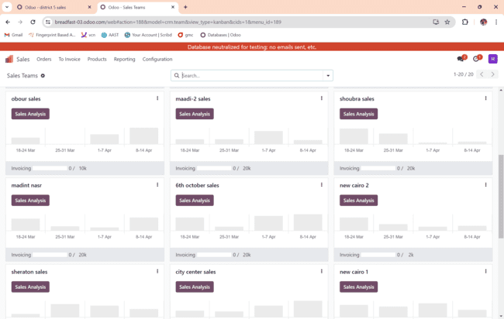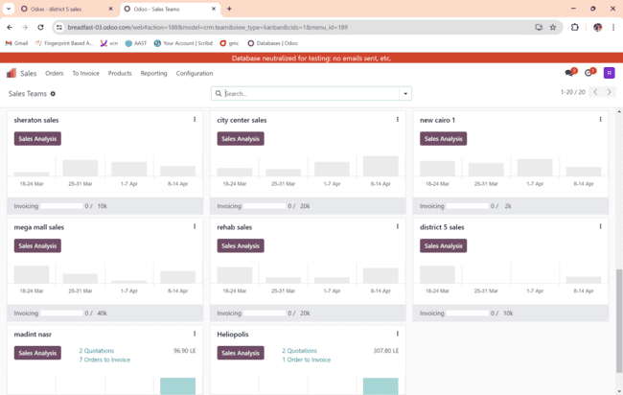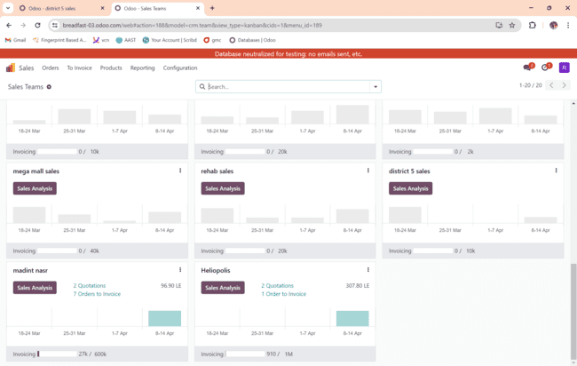

**5- Sales Order – Operations:**

**A-**Quotation

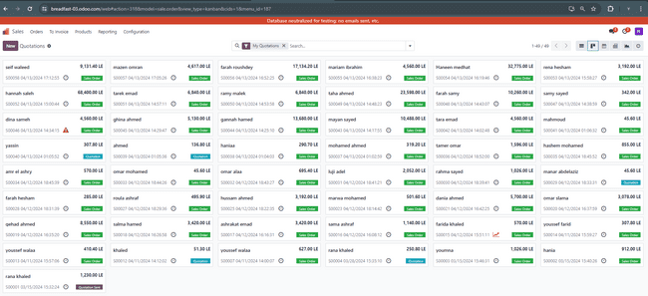

**B-** Apply Return products on Sales Order after Payment (Credit note).

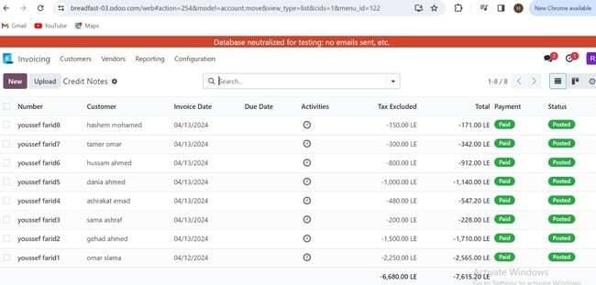

Example:

Gehad returned 10 units from the 50 units of automatic wash gel she ordered.

Example 2:

Sama returned 10 brown crackers from the 20 units she ordered.

Example 3:

Hussam returned 20 units from the 70 units of full cream milk he ordered.

Example 4:

Ashrakat returned 20 units from the 50 units of crackers she ordered.

C-. Apply SO with register payment (partially by one invoice).

Tara ordered 200 units from lays classic and paid 2500 as her first installment and 2060 as her 2nd insatllment

1. Apply SO with register payment on invoiced installments (Many invoices for one sales order).

Rena Hesham paid 35% of her order on 13/4 then paid 65% on 13/5 in different invoices.

Haneen Medhat ordered 115 units from persil deep clean and paid on 3 installments with different invoices.

Mariam Ibrahim ordered 200 units of lays cheese and paid on 3 installments with 3 different invoices.

Farah Roushdy ordered 167 units of Nutella jars and paid on 3 installments with 3 different invoices.

Mazen Omran ordered 270 units of apple juice and paid in 3 installments with 3 different invoices.

Seif Waleed ordered 270 units from domty plus cheese in 3 installments with 3 different invoices.

6. Purchase – Reporting:

a- List all the vendors.

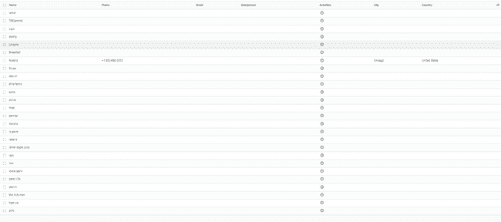

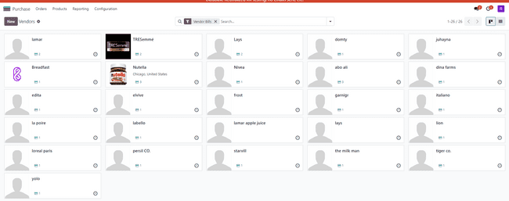

In this step, we show all the vendors. We have more than 26 vendors.

b- List all vendors’ pricelists.

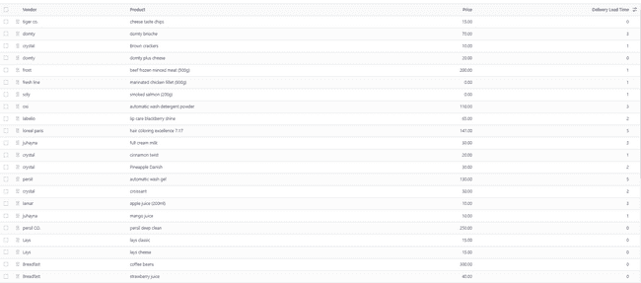

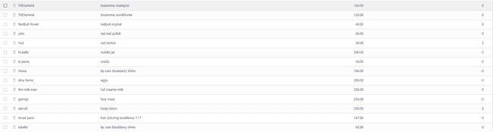

c- List all the Purchase order with different status.

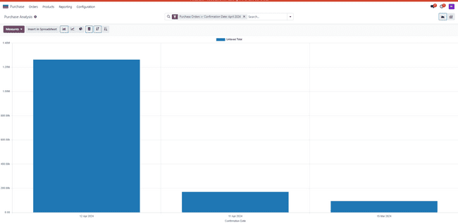

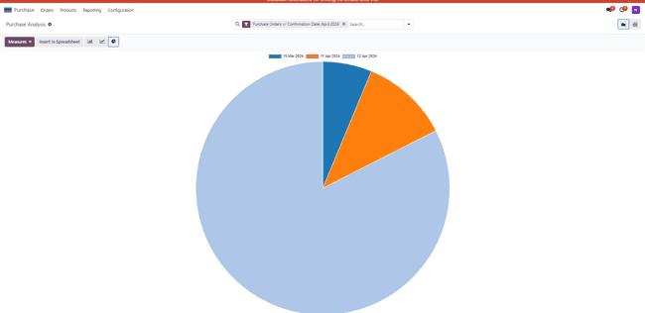d- Pivoting the sales order with grouping the total product category and the warehouse.

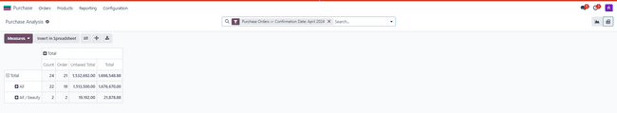

e- Graph all the Purchase analysis group by the vendor.

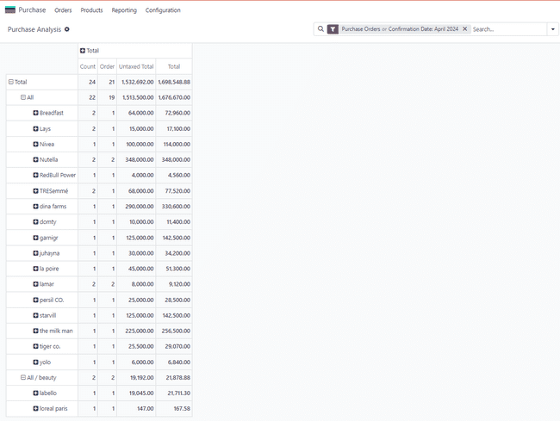

f- Graph all the Purchase analysis group by Product.







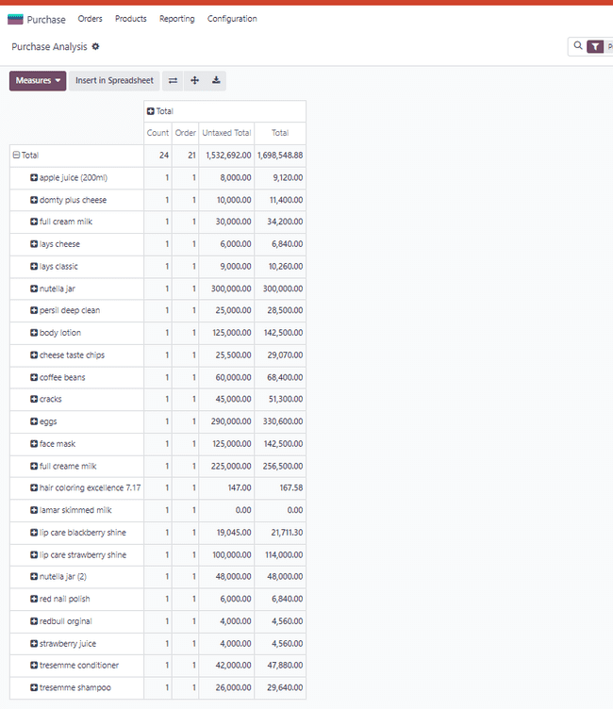

g- Graph all the Purchase analysis group by vendor.

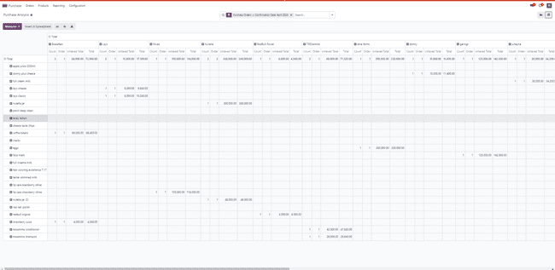

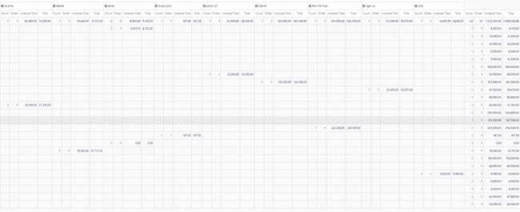

h- Graph all the Purchase analysis group by warehouse.

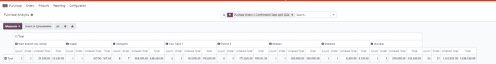

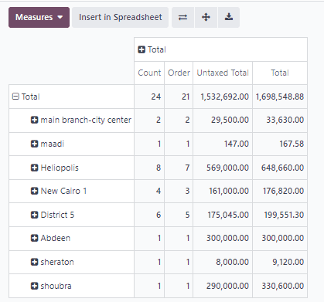

7.Sales-Reporting

a- List all the sales orders with its status. 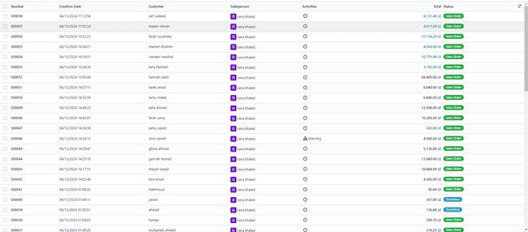

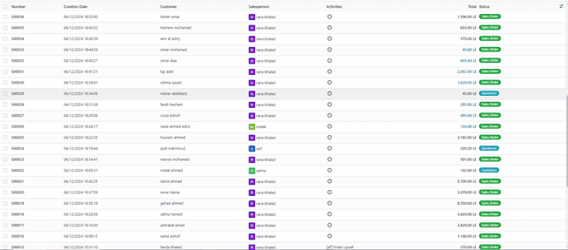

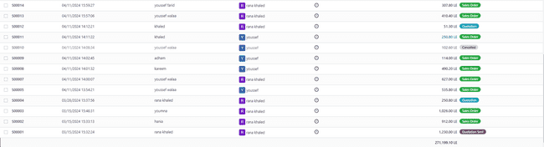

Group by salesperson

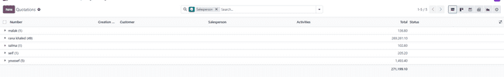

Filter by quotations

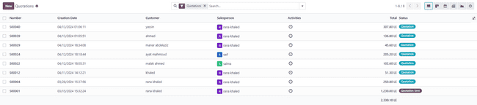

b- Show the sales order by Pivot group by warehouses and the products & customers.

group by warehouses and customer

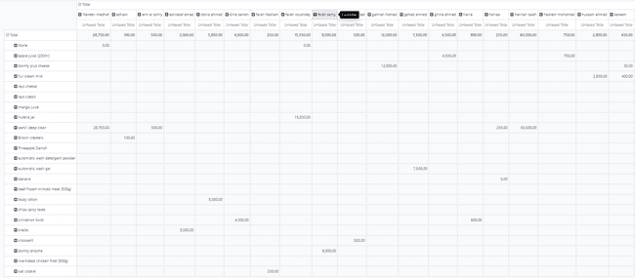

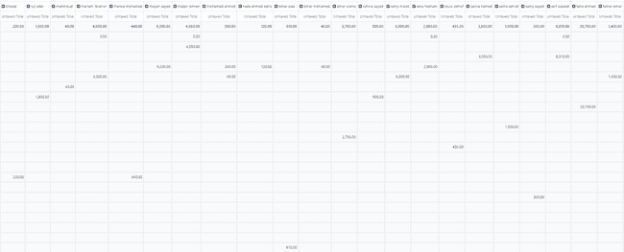

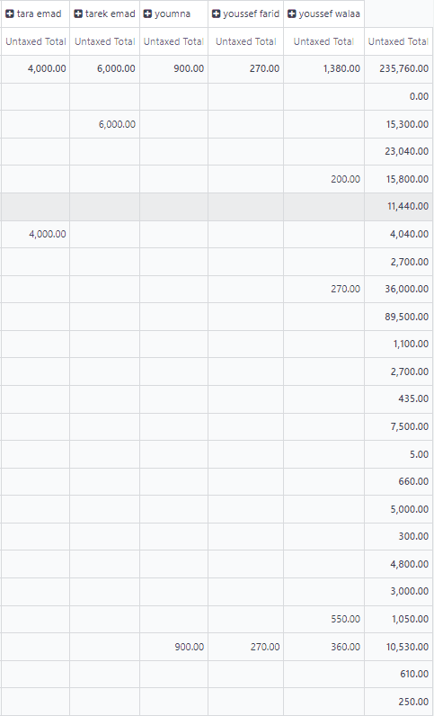

group by warehouses and products

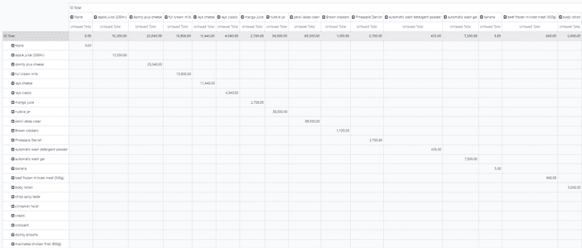

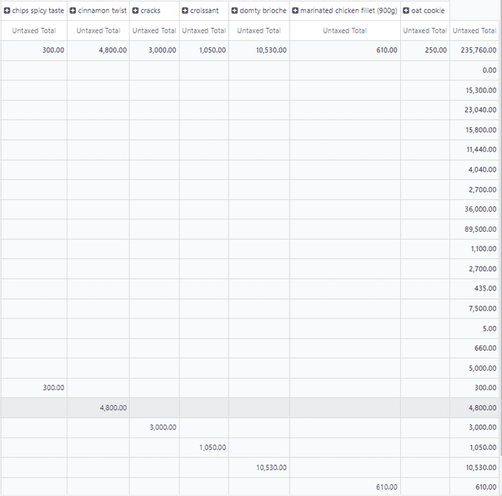

c- List all the customers.

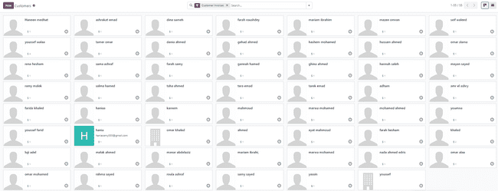

d- Graph all sales analysis by sales person group by sales team.

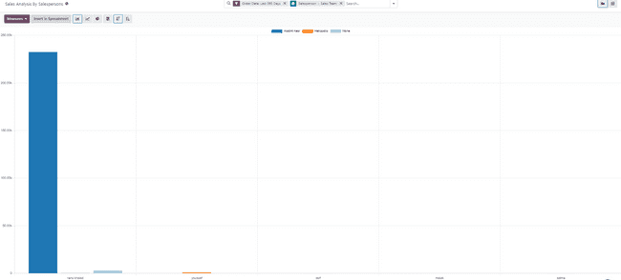

e- Graph all sales analysis by products.

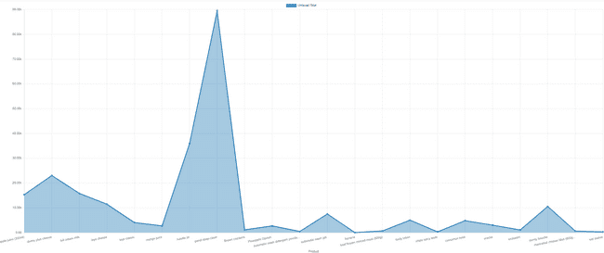

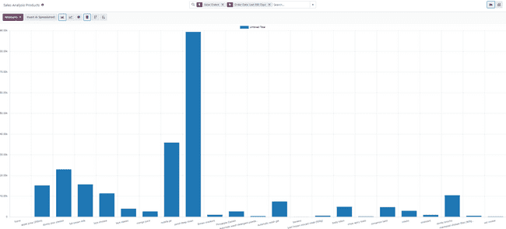

f- Graph sales analysis by customers.

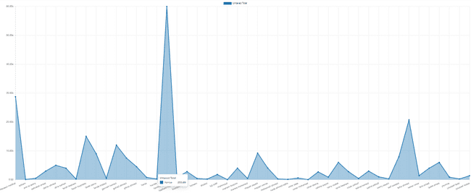

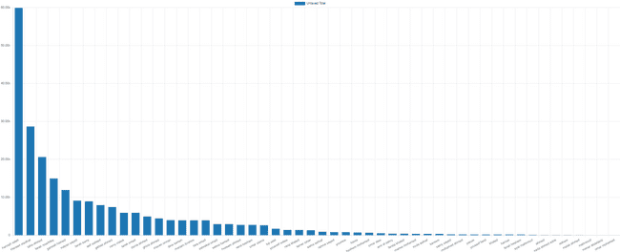

g- Graph all sales analysis group by warehouses.

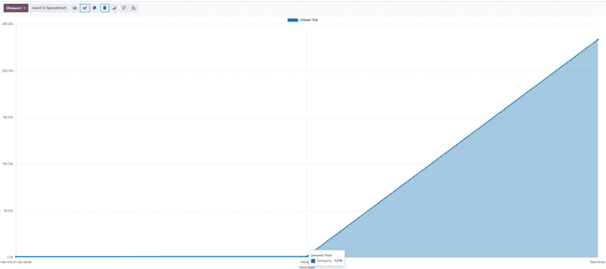

h- Show Sales team Dashboard that show the highest sales team performance.

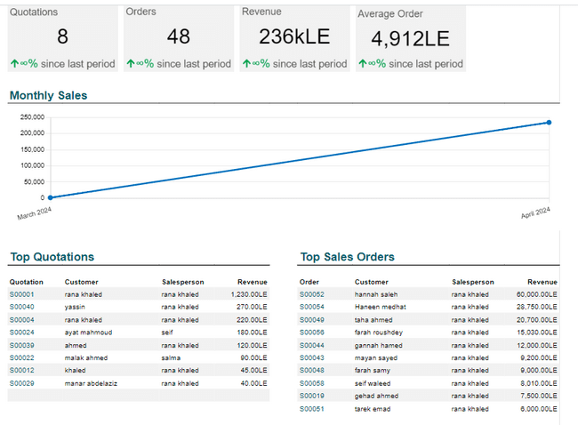

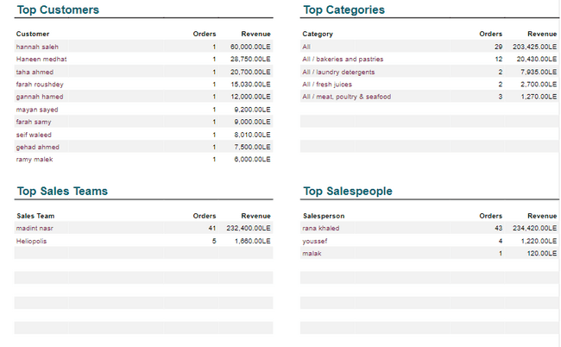

8.inventory -reporting:

a. list of warehouses and locations:

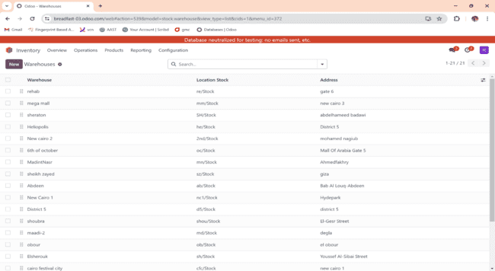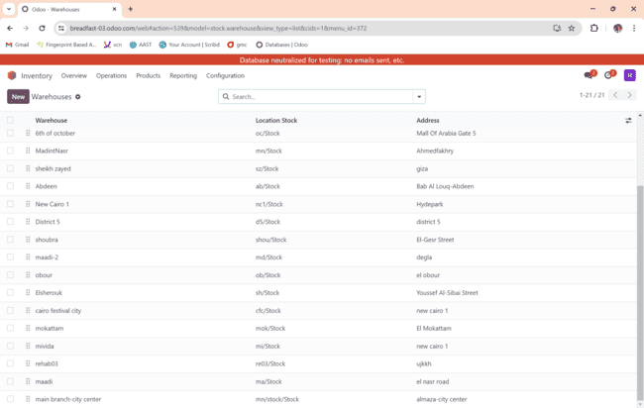

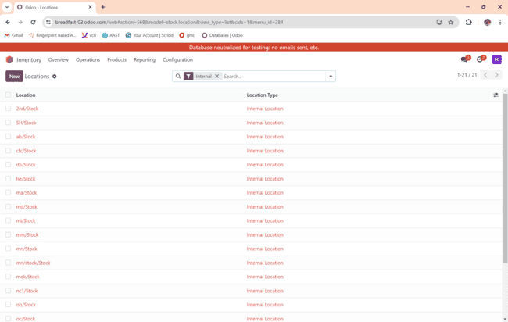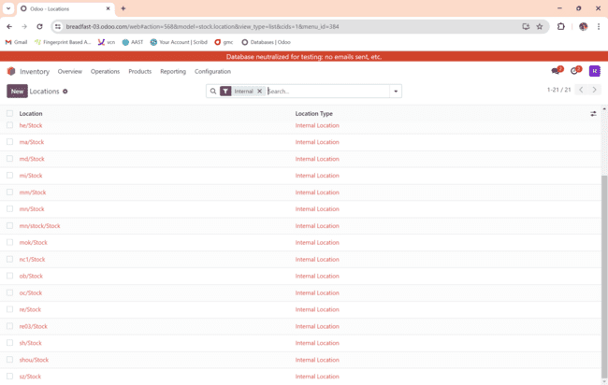

We have 20 warehouses all over Egypt.

2.list of reordering rule:

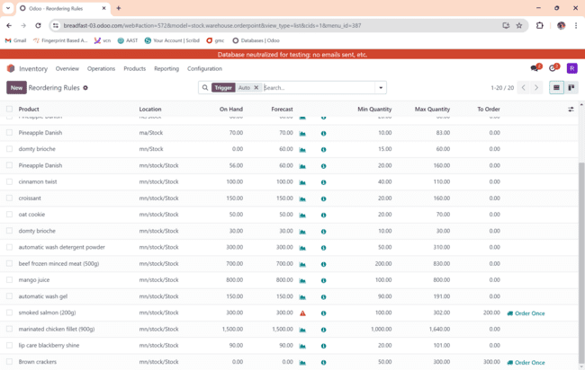

We have to define the min quantity, max quantity and to order.

3. list of product categories:

We have more 20 product categories beside the 5 that are already created by odoo.

4.list of products:

We created 20 products at the beginning of the project then the rest were added during the project ”each group member has created 5 products”.

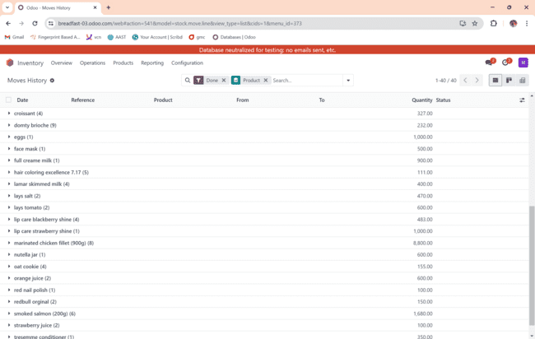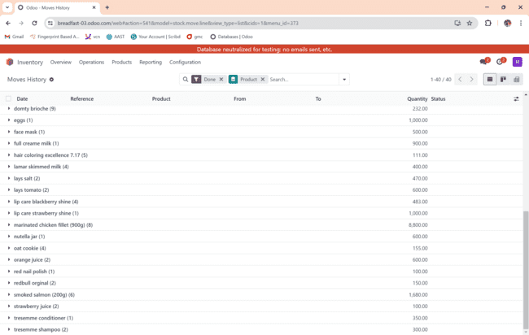

e.list of moves history grouping by locations:

e.list of moves history grouping by transfers:

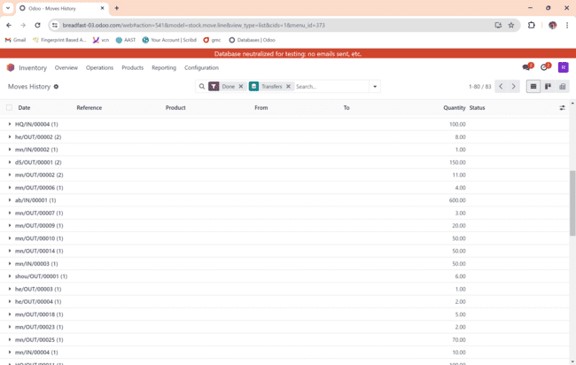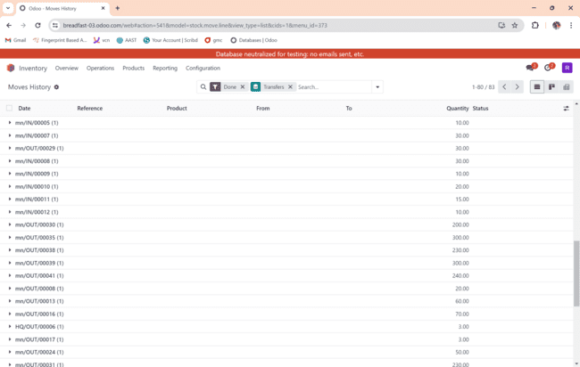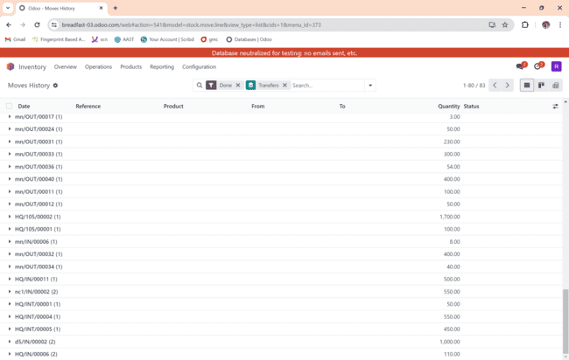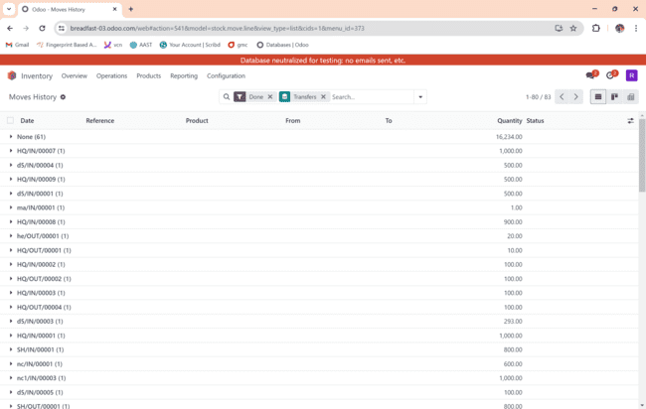

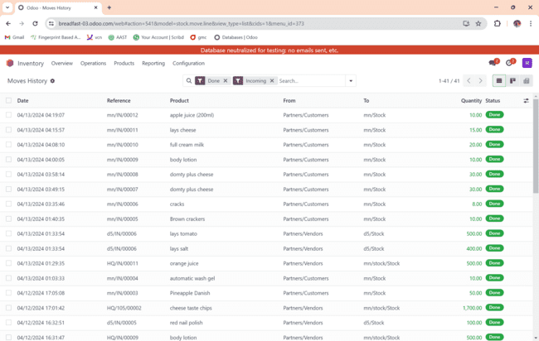

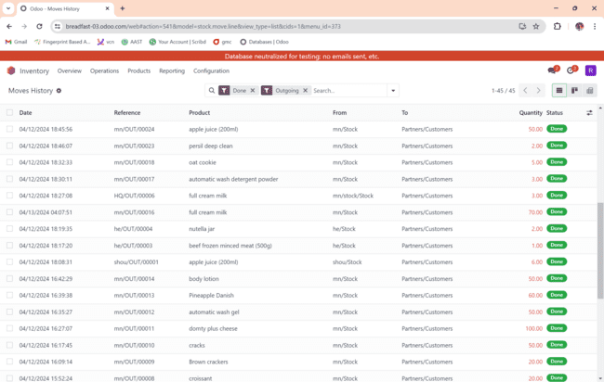

g. pivoting moves history:

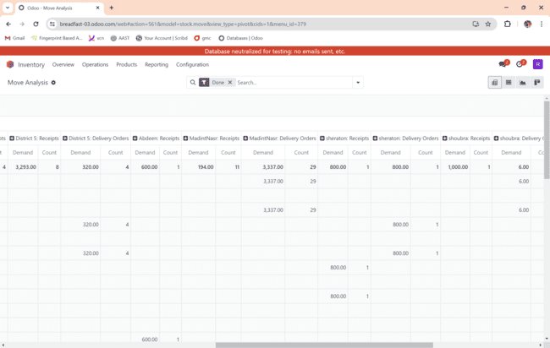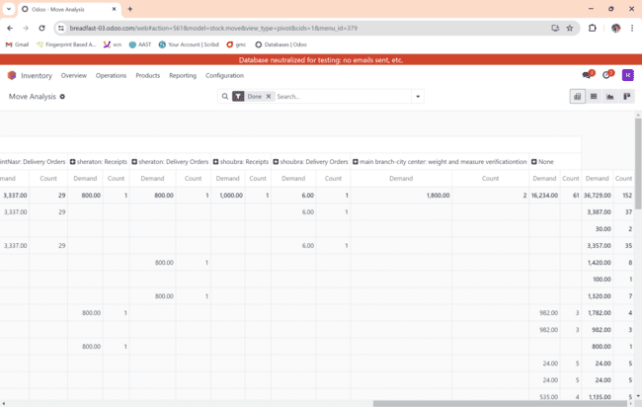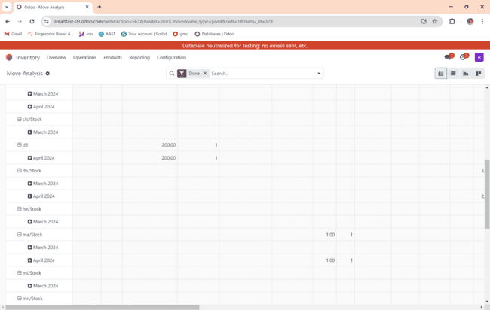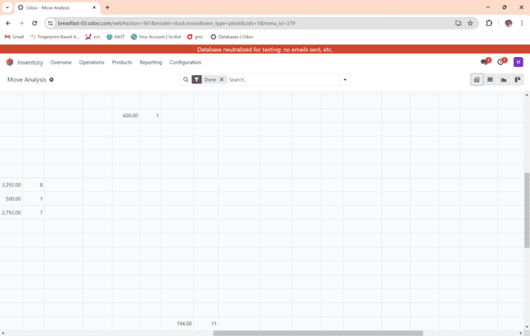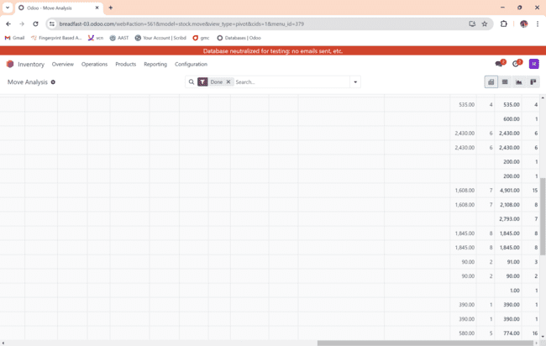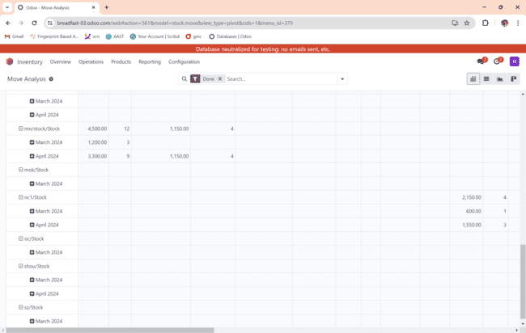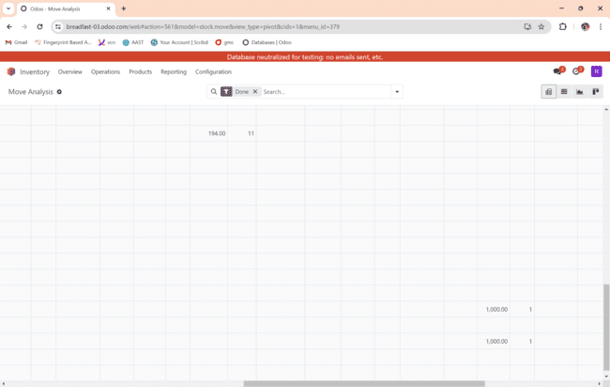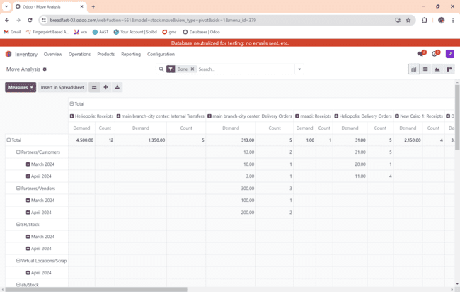

h.list of scrap:

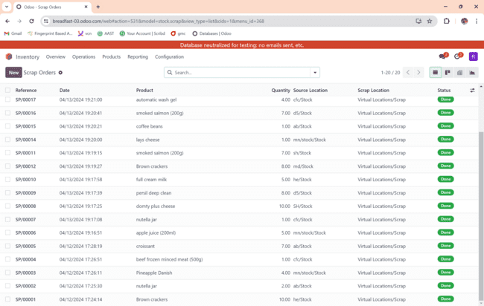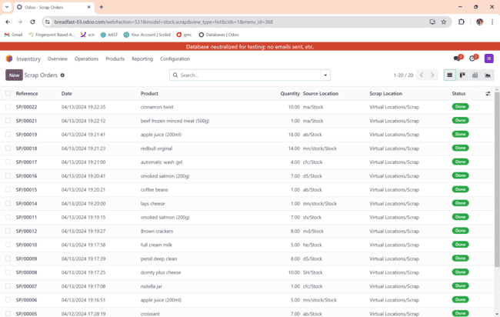

h.list of return:

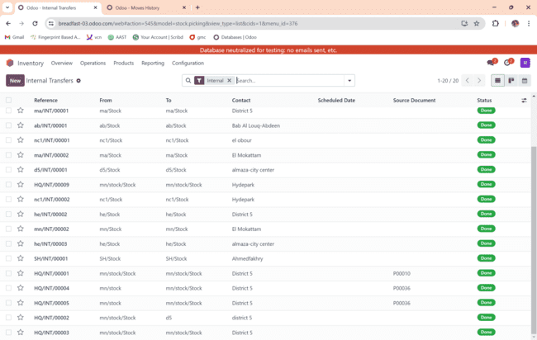

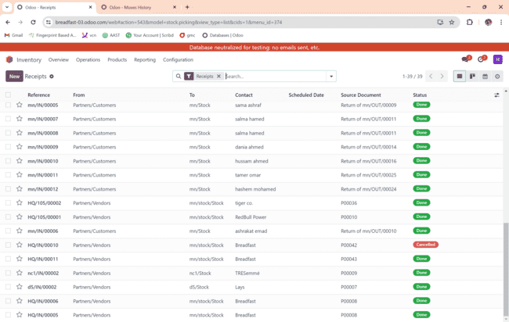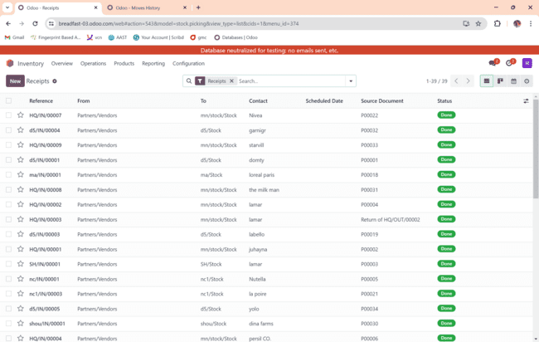

h.list of deliveries:

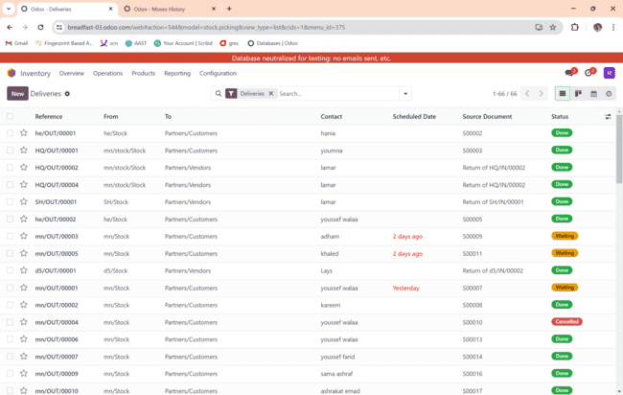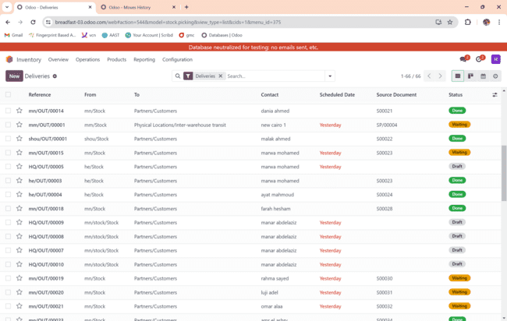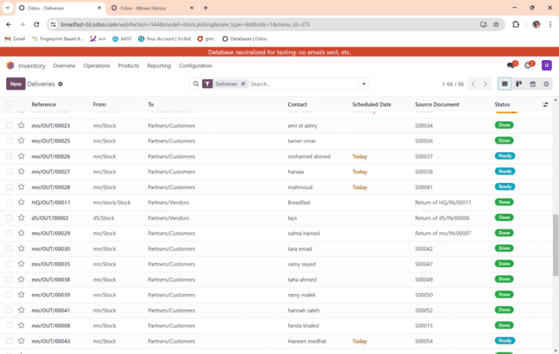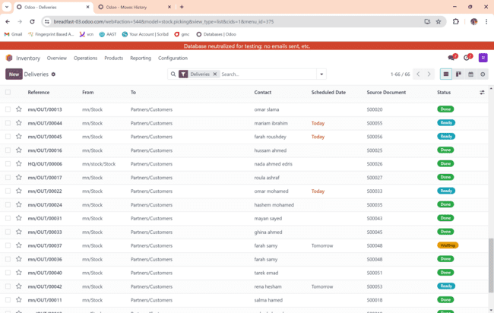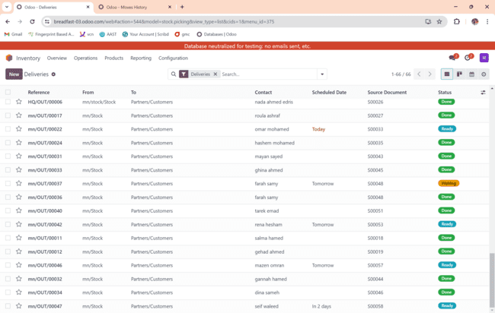

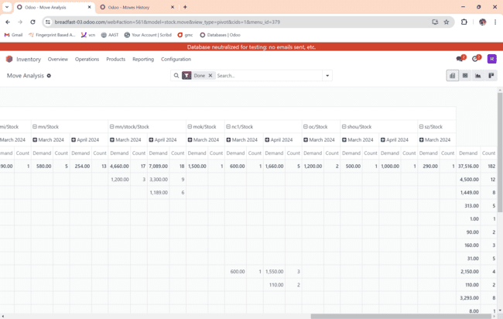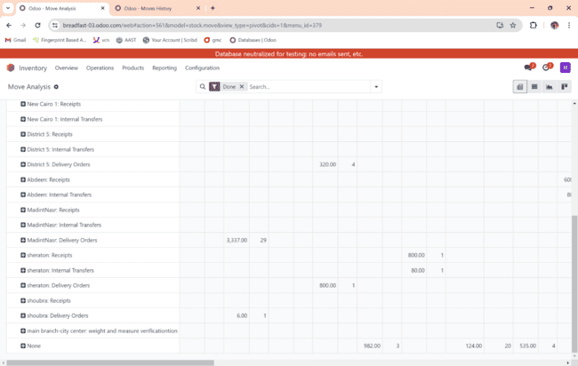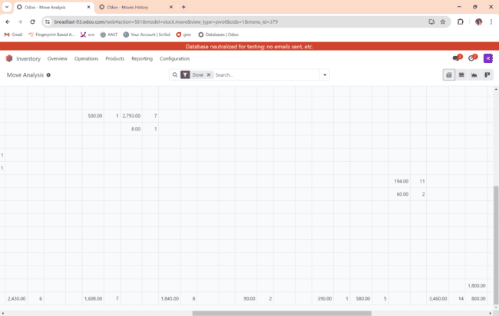

k. graph performance group by product:

1. List all physical inventory group by product:

m. list replenishment group by warehouse:

m.list of replenishment group by location:

